Safe Work Method Statement (SWMS) **insert job / project name here**

All work undertaken at the Simtars’ Redbank or Mackay facility must be performed in accordance with your organisation’s Safe Work Method Statement (SWMS). This template is provided if you do not currently have an organisational SWMS. This SWMS must be kept and be available for inspection until the work to which this SWMS relates to, is completed. If the SWMS is revised, all versions should be kept. If a notifiable incident occurs in relation to the work in this SWMS, the SWMS must be kept for at least two years from the date of the notifiable incident.
Simtars’ contact person: |  |  |  |  | Contractor’s name:
Simtars’ contact number: |  |  |  |  | Contractor’s contact number:
Date this SWMS was provided to Simtars: |  |  |  |  | Location where work is to be performed at Simtars:
Description of work to be undertaken:
Please tick all that are applicable or identify other hazards that might apply:
☐ Y  ☐ N | Risk of a person falling more than two metres |  | ☐ Y  ☐ N | Temporary load-bearing support for structural alterations or repairs |  | ☐ Y  ☐ N | Demolition of load-bearing structure
☐ Y  ☐ N | Work in or near a shaft or trench deeper than 1.5 m or a tunnel |  | ☐ Y  ☐ N | Work in or near a confined space |  | ☐ Y  ☐ N | Work on or near pressurised gas cylinders or lines
☐ Y  ☐ N | Work on or near chemical, fuel or refrigerant lines |  | ☐ Y  ☐ N | Work on or near energised electrical installations or services |  | ☐ Y  ☐ N | Work in an area that may have contaminated or flammable atmosphere
☐ Y  ☐ N | Does any equipment or machinery require electrical or mechanical isolation? |  | ☐ Y  ☐ N | Exposure to mobile plant or vehicles |  | ☐ Y  ☐ N | Work in an area with movement of powered mobile plant
☐ Y  ☐ N | Work in areas with artificial extremes of temperature |  | ☐ Y  ☐ N | Work in or near water or other liquid that involves risk of drowning, e.g. tanks |  | ☐ Y  ☐ N | Work outside of the hours of 6am – 6pm
☐ Y  ☐ N | Hot work (welding, grinding, cutting) |  | ☐ Y  ☐ N | Vibration (whole body, hand, arm etc) |  | ☐ Y  ☐ N | Excessive noise
☐ Y  ☐ N | Dust generation |  | ☐ Y  ☐ N | Machinery or entrapment sources |  | ☐ Y  ☐ N | Does the work or equipment to be used require a specific licence (Provide detail in the table below)?
☐ Y  ☐ N | Are any dangerous goods or hazardous substances being used? |  | ☐ Y  ☐ N | Radiation (UV, welding flash, ionising) |  | ☐ Y  ☐ N | Potential exposure to pollutants, toxic gases or vapours
☐ Y  ☐ N | Power tools / explosive tools |  | ☐ Y  ☐ N | Compressed gas or air / hydraulic equipment |  | ☐ Y  ☐ N | Manual Handling / lifting
☐ Y  ☐ N | Repetitive movement |  | ☐ Y  ☐ N | Environmental hazards, e.g. snakes |  | ☐ Y  ☐ N | Has electrical equipment been tested and tagged (i.e. is it current)
☐ Y  ☐ N | Other (specify) |  | ☐ Y  ☐ N | Other (specify) |  | ☐ Y  ☐ N | Other (specify)

What are the tasks involved? | What are the hazards and risks? | What are the control measures? |  | Risk rating?
Refer to the tasks identified and ticked ‘Y’ in the table above. List these work tasks in a logical order. | Identify the hazards and risks associated with the tasks identified ’Y’ in the table above and that may cause harm to workers or the public. | Describe what will be done to control the risk. What will you do to make the activity as safe as possible? Consider the Hierarchy of Control – see diagram in Analysis of Risk pages below. |  | Refer to the risk matrix in the Analysis of Risk pages below and rate the risks Low, Medium or High
Overall Risk Rating for this work: |  |  | ☐ Low  ☐ Medium  ☐ High

SWMS sign off by workers: This SWMS has been developed is consultation and cooperation with workers and relevant organisation representatives. I have read the above SWMS, and I understand its content. I confirm that I have the skills and training, including relevant certification, to conduct the tasks described. I agree to comply with safety requirements within this SWMS, including risk control measures, safe work instructions and PPE described.
Name of worker/s | Relevant license details |  |  |  | Worker/s signature | Date
 | Type | Class | Number | Expiry date
Name of contractor responsible for ensuring compliance of workers with this SWMS: |  |  | Signature: |  | Date:
Name of Simtars’ person approving the use of this SWMS: |  | Approved:  ☐ Yes  ☐ No | Simtars approver’s signature: |  | Date:
If not approved, please provide the reasons:
Notes:

ANALYSIS OF RISK

RISK LEVEL DESCRIPTORS
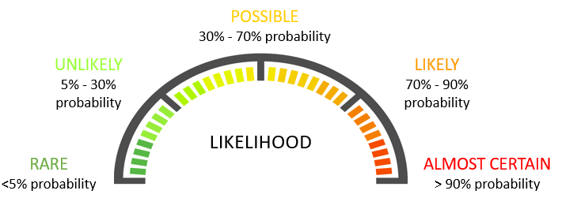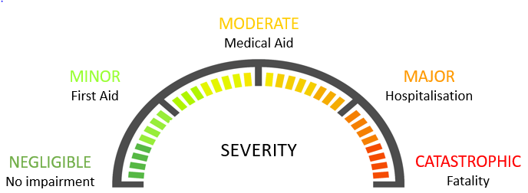

RISK LEVEL VALUES
Risk Level Rating |  | Likelihood
 |  | Rare | Unlikely | Possible | Likely | Almost certain
Severity | Catastrophic | Medium | High | High | High | High
 | Major | Medium | Medium | High | High | High
 | Moderate | Low | Medium | Medium | Medium | High
 | Minor | Low | Low | Low | Medium | Medium
 | Negligible | Low | Low | Low | Low | Medium

HIERARCHY OF CONTROLS

