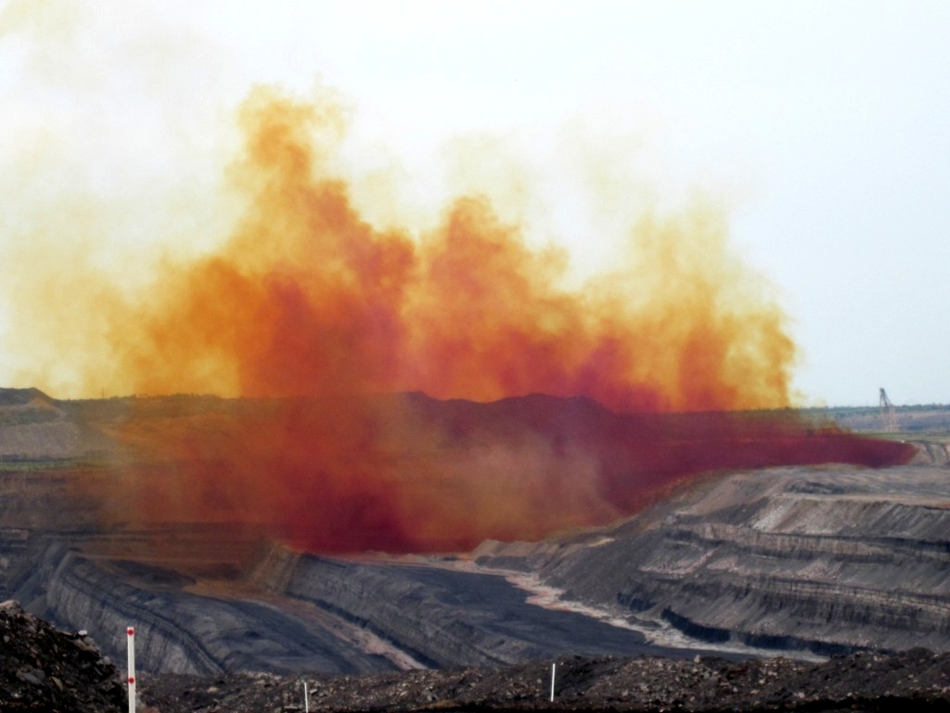
Fume Investigation
Fume Investigation

Contents
Executive summary

- Introduction and Background

- Findings

- Conclusions

- Recommendations

- Responsibility and accountability

- Blast Designer

- Shotfirer

- Driller

- Blast Controller

- Shotfirer Supervisor

- Drill and Blast Supervisor

- Team members

2. Blast location

- Description

- History of blasts from site location

3. Geology

Material Type | Density | UCS  (MPa) | Youngs  Mudulus  MPa  (usually GPa) | Poissons  ratio | Tensile  strength  (MPa)

4. Moisture content before and after blast

- Presence of water

5. Blast design

Summary Table
Shot number
Shot type
Hole diameter
Hole depth
Stemming
Burden and spacing
Drill angles
Total volume
Number of holes
Explosives used
Design Quantities
Emulsion
Stemming
Initiation
Timing
Priming
Primer location
Water

6. Blast plan

7. Hole depth measurements

8. Charging plan

- Actuals

9. Timing plan

10. Stemming Type

11. Dewatering

- Which holes
- Gas bags
- Recharge rates
- Redipped

12. Blast charging

Charging problems
Charging accuracy
Final stemming height
Dip sheets
Load sheets
Air bag use
verses
Planned

13. Procedures

- Blast
- Variations
- JSRA
- Priming position

14. Blast monitoring

Video | Number
Log
Records from blast guards
Observations
Personal monitors
Field monitors

15. Quality control

- Emulsion and AN certificates

- AN bulk density

- EP temperature

- MMU Calibration
- Product density
- Raw material fumes or crystallisation
- Fuel Specification
- Charges to MMU settings
- Issues with deliveries
- Storage period

16. Training
- MMU

- Shotfirers

- Blast Designer

17. Weather

Wind direction and speed
Cloud cover and height
Signs of inversion
Temperature
Rain / storms in the area
Fume modelling
Weather observations (before/during/after)
Firing

18. Fume risk management plan

Discussion

Water attack on AN

Groundwater level

Fume generation mechanism

Initiation design

Explosives selection

QA checks

Procedures

- Personal statements

- Photos and videos of blast

- Extracts

